# Abstract

[To write]

# Structure

## Introduction

Atrial fibrillation (AF) is a progressive condition affecting approximately [XXX] people in the UK each year. AF raises the lifetime risk of having a stroke, and so effective management of AF and the associated stroke risk is important [WHY? – I.E. REDUCE MORTALITY & MORBIDITY]. Oral anticoagulants (OACs), such as warfarin, dabigatran and rivaroxaban, reduce the risk of stroke,[REFS] but carry a non-trivial risk of major bleeding events, which in some cases lead to death or levels of disablement equivalent to or worse than the strokes they aim to prevent. They are also relatively expensive, either directly due to drug acquisition costs in the case of new drugs like dabigatran and rivaroxaban, or indirectly due to monitoring costs in the case of warfarin.

Because [DON’T START SENTENCE WITH BECAUSE] both the costs and risks associated with OACs are non-trivial [USED WORD PREVIOUSLY], it is important to identify those patients for whom the benefits are likely to outweigh the risks. This means using diagnostic approaches to try to assess patients’ stroke risk, in order to target OAC prescription towards those at a higher risk. Currently clinical prediction rules using patient history and characteristics – CHADS2 & CHADS-VASc- are used to make this decision. Though inexpensive, due to not requiring additional testing, such clinical prediction rules can be wrong, which may lead to either overmedication of genuinely low risk patients (‘false positives’) or undermedication of genuinely high risk patients (‘false negatives’). Either of these outcomes can be suboptimal in their consequences [AREN’T OUTCOMES THE SAME AS CONSEQUENCES], both directly in terms of medication costs, and indirectly in terms of reduced and duration of life and increased costs due to major bleeding events cause by their use.

Because [BAH!] the consequences of wrong OAC prescription decisions can be so severe, we [USE THIRD PERSON] wanted to determine whether performing an additional, slightly more expensive diagnostic test in all newly diagnosed AF patients would lead to net improvements in clinical effectiveness. If performing this test were clinically effective, we want to know if it is cost-effective at standard NICE decision-making thresholds [SOUNDS A BIT SOFT HERE – WRITE MORE FORMALLY]. Our [3RD PERSON] additional diagnostic test of interest is transthoracic echocardiography (TTE). [Brief description of TTE including ref].

In this study we developed a discrete event simulation (DES) to model the long-term implications of performing TTEs in all newly diagnosed AF patients when making the decision whether to prescribe OACs. In the model presented below dabigatran was selected as the OAC to model, as it has recently been recommended for use in this population group by NICE [Ref], and carries a lower bleed risk than warfarin. [Ref] TTE is modeled as an addition to using two variations of a common clinical prediction rule for assessing stroke risk: CHADS2 and CHADS-VASc. Patients whom the prediction rule would suggest are of lowest stroke risk, and so would not normally be prescribed OAC, are also assessed using TTE. If TTE identifies at least one type of left atrial abnormality (LA ABN), which has been shown to lead to an increased stroke risk, [Ref] then they are also prescribed OACs. Note that as a result of this, more people will be prescribed OACs when TTE is included in the diagnostic package than when it is not; any potential cost savings would be as a result of preventing strokes and the costs to the NHS that result from them.

## Method

An overview of the model is presented in Figure 1. The model involves both a short-term stage in which the clinical characteristics of a patient are generated, and the decision whether or not to prescribe OAC is made, and a long-term simulation of the clinical outcomes, and associated costs and utilities, that follow from the patient’s clinical characteristics and the decision whether or not to prescribe OAC.

**Figure 1: Graphical Representation of the mathematical model [NICE DIAGRAM!]**

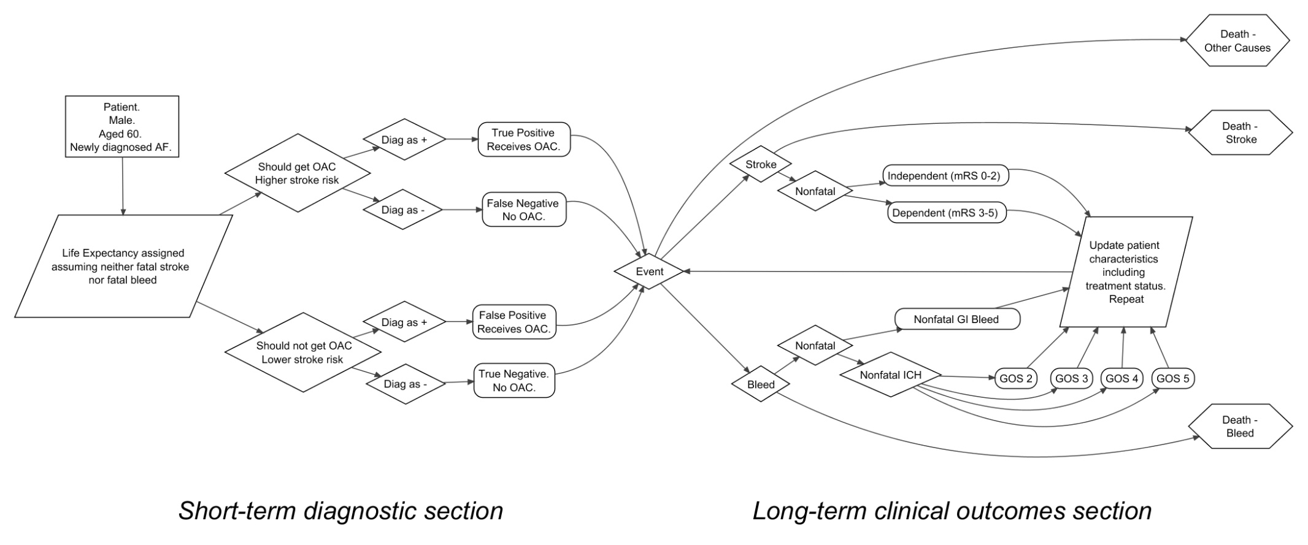

Two related diagnostic tools are commonly used to make the decision about whether to prescribe anticoagulants in newly diagnosed AF patients: CHADS2 and CHA2DS2-VASc. [REFS NEEDED] CHADS2 is the more established instrument, and has published risk levels associated with each group [REFS NEEDED]. The CHADS2 instrument produces a risk score for each patient ranging from zero to six points inclusive, assigning individuals a risk score of one point for a history of congestive heart failure (C), hypertension (H), being aged 75 years or older (A) or having diabetes (D), as well as two points for having had a prior stroke or TIA (S2). Similarly, CHADS2-VASc assigns patients a score ranging from zero to nine points, differing from CHADS2 in that one point is assigned for being aged 65 or more, an additional point for being aged 75 or more, one point is assigned for a history of vascular disease, and one point assigned for being female [CAN YOU SHOW THE ALGORITHMS IN A BOX? WOULD MAKE IT EASIER TO UNDERSTAND]. In both cases, it is assumed a patient assigned a risk score of one or more point would be prescribed dabigatran. As a result of this, CHADS2-VASc is a more inclusive clinical prediction system.

In our [3RD PERSON] comparator strategy, in which information from TTE is used alongside that from the standard clinical prediction rule, the decision to coagulate can also be made as a result of TTE identifying a structural feature of left atrial abnormality (LA ABN) that predisposes an individual to a high risk of stroke.135 For the purposes of this report we define LA ABN as a patient having either a left atrial appendage thrombi, a dense spontaneous echo contrast, or left atrial appendage low flow velocities.

The short term model looks at the effect of including TTE in the diagnostic strategy on the proportion of newly diagnosed AF patients from four mutually exclusive and exhaustive patient groups. We define these groups as: 1) true positives (TPs): patients with a clinical prediction score of one or more. These patients would currently receive dabigatran. 2) true negatives (TNs): patients with a clinical prediction score of zero, who also do not have an LA ABN, and whom TTE does not misclassify as having LA ABN. These patients currently do not receive the OAC, and for this patient group this is the correct decision. 3) False positives (FPs): Patients with a clinical prediction score of zero whom TTE misclassifies as having a LA ABN. As a result of this, using TTE would lead to these patients being given OACs even though for them this would be the wrong decision. 4) False negatives (FNs): Patients with a clinical prediction score of zero, but a LA ABN that TTE has failed to identify. These patients would not receive OACs even though for them prescribing OACs would be the correct decision.

Within our model, the clinical effectiveness and cost-effectiveness of TTE compared with no TTE is a function of the mixture of these four patient groups within the patient population, which is itself a function of 1) the true proportion of patients with a clinical prediction score of zero who have LA ABN and are thus at substantially higher stroke risk than predicted (‘True Proportion High Risk’ or TPHR); and 2) the sensitivity and specificity of TTE in identifying TPHR individuals. The patient mix is defined as: TPHR x Sensitivity for true positive, (1 – TPHR) x Specificity for true negative, (1 – TPHR) x (1 – Specificity) for false positive, and TPHR x (1 – Sensitivity) for false negative. Within the context of the model, the baseline strategy (no TTE) can be considered a diagnostic strategy with a sensitivity and specificity of zero, so the baseline population mix is comprised of TPHR% false negative and 1-TPHR% true negative. [I THINK YOU MIGHT LOSE THE READER HERE…]

Our estimates for sensitivity and specificity were drawn from a recent cross-sectional study of 405 AF patients. [Ref][SAY WHY THIS STUDY] For 334 of these patients the presence or absence of LA ABN features identified through TTE was cross-tabulated with those identified with a more expensive and invasive test, transoesophageal echocardiogram (TOE or TEE), which was taken to be the gold standard. TOE identified LA ABN in 92 patients; in 87 of these patients they were also identified by TTE. Conversely, TOE identified no LA ABN features in 242 patients; in 159 of these patients, however, TTE appeared to identify a LA ABN feature. This implied a sensitivity for TTE of 0.946 (87 / (87 + 5)) and specificity for TTE of 0.343 (83 / (83 + 159)). Within probabilistic sensitivity analyses [YOU HAVEN’T SAID ANYTHING ABOUT PSA BEFORE – *********EARLY ON IN THE METHODS DEFINE THE POPULATION, INTERVENTION, COMPARATOR, HEALTH ECONOMIC OUTCOME, PERSPECTIVE, DISCOUNT RATE AND TIME HORIZON & MENTION THAT IT IS ASSESSED USING A PROBABILISTIC MODEL] the sensitivity and specificity were jointly estimated from a Dirichlet distribution with these four cell values. It was assumed that the derived distributions of sensitivity and specificity was applicable to all patients and was thus assumed applicable to patients who had a CHADS2 score of 0 and to patients with a CHA2DS2-VASc score of 0.

The same cross-sectional study was used to estimate TPHR for clinical prediction scores of zero. These data suggested a TPHR of 2/24 for CHADS2=0, and 0/11 for CHA2DS2-VASc=0. Given the small data available (the number in the LA ABN group being less than 5) an uninformative prior of 0.5 was added to each paired data set culminating in an expected 2.5 out of 25 patients expected to have a LA ABN amongst those with CHADS2 score of 0, and an expected 0.5 out of 12 patients with a CHA2DS2-VASc score of 0 to have a LA ABN. For PSA these values were used to populate Beta distributions.

The model simulates a series of 60 year old men with newly diagnosed AF but with [DODGY ENGLISH? – BUT WITH] none of the conditions that lead to a clinical prediction score of one or more. This means they would not currently be recommended treatment with an OAC. For this patient group the age at death (assuming no AF-, or AF treatment-related mortality) was simulated. The diagnosis, or not, of LA ABN following TTE was additionally simulated. The DES is dynamically updated when events occur that affect an individual’s CHADS2 or CHADS-VASc score, or other characteristics that affect their stroke or bleed risk. For example, when the patient reaches an age of 65, their CHADS-VASc score increases by one; at age 75 their score increases by one CHADS2 point, and their CHADS2-VASc score by an additional point. A stroke leads to an increment of two points on the CHADS2/CHADS2-VASc score. If a patient suffers a major bleeding event after taking OACs, they stop being prescribed the OACs, leading to the risk of bleeds reducing to zero, but the risk of stroke increasing. If a patient experiences a stroke and are not already taking an OAC, they are prescribed OACs. If a patient suffers a severe intracranial haemorrhage (Glasgow outcome scale category 2) as a result of taking OACs, their life expectancy was reduced to a maximum of 3.4 years. Additionally, the risk of a major bleeding event when taking Dabigatran (150mg twice daily) was also assumed to change at the age of 75.

The probability of a 60-year old man dying in each of the forthcoming year was taken from UK life tables.137For simplicity, it was assumed that all remaining patients would die within their 101st year. We assumed that higher CHADS2 scores were associated with a higher risk of stroke. Our estimates were based on results presented in Gage et al,138 which presented adjusted stroke risks assuming no aspirin.138 In order to ensure no estimated risks were less than zero within the PSA, estimates were simulated from a lognormal distribution. Quantiles from the simulation were paired in order to reduce the probability of monotonicity within the PSA. These estimates are presented in Table 1. Patients with LAA were assumed to have a risk of stroke independent of CHADS2 score. The risk was set as 8.0% (95% CI 7.26 - 8:31) per annum, as reported in Connelly et al.139 For simplicity the risk of stroke was assumed to apply throughout the lifetime of the patient. No data were found for the risk of stroke associated with CHA2DS2-VASc scores. For simplicity, we assumed the risk of stroke associated with each CHA2DS2-VASc score was equivalent to the corresponding CHADS2 scores (Table 27). This is acknowledged as a limitation in the CHA2DS2-VASc analysis.

**Table 1: The assumed risk of stroke associated with CHADS2 score**

|  |  |
| --- | --- |
| CHADS2 score | Annual Risk (95% CI) |
| 0 | 1.9 (1.2 to 3.0) |
| 1 | 2.8 (2.0 to 3.8) |
| 2 | 4.0 (3.1 to 5.1) |
| 3 | 5.9 (4.6 to 7.3) |
| 4 | 8.5 (6.3 to 11.1) |

The risk of major bleeding events in patients receiving dabigatran was estimated using a simulation approach based on results published using data from the RE-LY trial.142 2 presents credible intervals, based on imputed sample sizes, for these two age groups.

**Table 2: Simulated Credible Intervals (CrI) for the annual risk of bleed on dabigatran**

|  |  |  |  |
| --- | --- | --- | --- |
| **Age group** | **Central estimate** | **Presumed Sample size** | **95% CrIs** |
| Under 75 years | 2.12% | 3618143 | 1.66% to 2.60% |
| 75 years or above | 5.10 % | 2419144 | 4.22% to 5.99% |

We estimated the relative risk (RR) of having a stroke when prescribed dabigatran through a two-stage indirect comparison: the relative risk of warfarin compared with placebo was taken from a 2006 meta-analysis, 140 and estimates for the annual risk ratio (RR) of a stroke for patients given 150mg dabigatran twice daily compared with warfarin taken from a paper based on the Randomized Evaluation of Long-Term Anticoagulation Therapy (RE-LY) study.139 Table 3 shows summary statistics from these two papers, the simulated distribution produced by combining the two, and the density functions of the distributions.

**Table 3: Data on the reduction in stroke risk associated with each OAC**

|  |  |  |  |
| --- | --- | --- | --- |
| **Comparison** | **RR (95% CI or CrI)** | **Assumed distribution** | **Source** |
| RR: warfarin vs. placebo | 0.33 (0.24 to 0.45) | Lognormal | Lip & Edwards 2006139 |
| RR: dabigatran vs. warfarin | 0.66 (0.53 to 0.82) | Lognormal | Connolly et al 2009139 |
| RR: dabigatran vs. placebo | 0.22 (0.15 to 0.32) | Lognormal | Derived from above |

We used an estimated cost for TTE of £66, taken from the HRG (Code RA60Z, Simple Echocardiogram)[Ref] Consideration was given to the use of alternative values for the cost of a TTE. However, on viewing the initial results it was seen that a small change in the cost of TTE would not materially alter the cost per QALY as the main component of incremental costs were the costs associated with prescribing OACs minus any savings in the reduced numbers of stroke plus any additional costs associated with bleeding episodes. The cost of dabigatran was assumed to cost £821.25 per year, assuming two 150mg tablets daily at a cost of £2.52 per day.132 This cost is fixed within all runs of the PSA. The costs of clinical events were divided into one-off costs, and ongoing costs. Estimates used are summarized in table [XXX]. Further details are provided in [Ref to either HTA and/or associated article].

Three mutually exclusive outcomes could result from a stroke: death, a dependent state, and an independent state. Each outcome has different utilities, probabilities and costs. Similarly, three mutually exclusive outcomes could result from a major bleeding event: death, an intracranial (IC) bleeding event, or a non-intracranial (NIC) bleeding event (assumed to be a gastrointestinal bleed). The severity of an IC bleed can vary substantially, and this variation of outcomes was itself simulated using data based on outcomes categorized by GOS score following traumatic brain injury. The costs, probabilities, and utilities of outcomes following strokes and major bleeds are summarized in table XXX. The full methodology used to produce these estimates is presented elsewhere [REF]

For both CHADS2 and CHADS2-VASc as baseline strategies, we simulated the expected patient experience for a large cohort of patients, in terms of life expectancies at age 60, and the proportion of deaths attributable to either strokes or bleeds. From this we calculated the expected costs and QALYs associated with the baseline outcomes. The patient experiences were also estimated following the comparator strategies, where information from TTE was used as described above. The differences in costs and QALYs associated with the simulated patient experiences following both baseline (without TTE) and comparator (with TTE) strategies were used to estimate the incremental cost effectiveness ratio (ICER) of the comparator strategies compared with the baseline strategies, and so the cost-effectiveness of TTE in this context. Uncertainty in our estimates of the ICERs due to uncertainty in expected input parameter values were estimated using a nonparametric approach directly from PSA results. The probability that the comparator strategy is cost-effective at a wide range of maximum acceptable incremental cost effectiveness ratios (MAICERS) is presented in the form of cost-effectiveness acceptability curves (CEACs) and cost-effectiveness acceptability frontiers (CEAFs), and the probability of being cost-effective at the commonly quoted threshold of £20,000 per QALY is reported.

The expected value of perfect information (EVPI) was calculated. This provides the maximum level of investment that a funding body would be prepared to pay to eliminate all uncertainty in the decision problem.160. In calculating EVPI an estimation of the number of patients who will be affected by the decision is required. We have performed a crude estimate assuming that the incidence of AF was 1 per 1,000 person years (approximately the pooled rate for women and men aged 55 to 64 years reported by the Renfrew Paisley study).16 that there are 6.7 million people aged between 55 and 64 years in England and Wales,161 that 6% of people are in the CHADS2 0 category,136 and that the information is relevant for 10 years. These broad estimates indicate that around 70,000 people would benefit from the being no uncertainty regarding whether TTE is cost effective.

Although a full expected value of perfect parameter information (EVPPI) was not calculated for computation reasons, sensitivity analyses were undertaken on two key parameters, the TPHR, and the joint uncertainty in the sensitivity and specificity of TTE in detecting LA ABN.

## Results

Table 4 shows the shows the simulated patient experience when TTE is added to either CHADS2 or CHADS2-VASc, in terms of clinical events. It is seen that the use TTE increases the expected life of patients, and increases the proportion of patients that die of non stroke- or bleed-related causes. An initial TTE reduces the estimated number of strokes but at the expense of a greater number of bleeds.

**Table 4: Simulated Patient Experience: Patients with a clinical prediction rule score of 0**

|  |  |  |  |  |  |  |  |  |  |
| --- | --- | --- | --- | --- | --- | --- | --- | --- | --- |
|  | |  | Cause of Death (%) | | | Average Number of Events | | | |
|  | Strategy | Life Years | Stroke | Bleed | Other | Dep. Strokes | Ind. Strokes | ICH | NICH |
| CHADS2 | No initial treatment | 20.024 | 12.2 | 1.4 | 86.4 | 0.115 | 0.262 | 0.011 | 0.082 |
| TTE with those diagnosed with LA ABN  treated | 20.175 | 10.9 | 1.8 | 87.3 | 0.104 | 0.235 | 0.014 | 0.109 |
| CHADS2-VASc | No initial treatment | 19.777 | 14.6 | 1.6 | 83.9 | 0.140 | 0.311 | 0.012 | 0.092 |
| TTE with those diagnosed with LA ABN  treated | 19.823 | 14.0 | 1.9 | 84.1 | 0.136 | 0.298 | 0.014 | 0.111 |
| TTE = Transthoracic Echocardiography; LA ABN = Left Atrial Abnormality; ICH = Intracranial haemorrhage; NICH = Non- intracranial haemorrhage | | | | | | | | | |

Table 5 shows the costs, QALYs, and ICERs associated with the simulated patient experiences presented in table 4. For CHADS2, the mean cost per QALY of below £6000 indicates that TTE is likely to be a cost effective use of resources. For CHADS2-VASc, the mean cost per QALY of almost £50,000 suggests TTE is not likely to be cost-effective in this context. Our 95% credible intervals for the ICERs range from dominating to almost £30,000 per QALY for CHADS2, and from less than £6,000 to dominated for CHADS2-VASc. These correspond directly to the joint estimation of costs and QALYs resulting from the PSA, as shown in figure 2(a) and figure 2(b). For figure 2(a) (CHADS2), a significant proportion of the estimates are in the south east quadrant, indicating simple dominance over the baseline strategy. For figure 2(b) (CHADS2-VAsc), a significant proportion of the estimates are in the north-west quadrant, indicating that the comparator strategy (CHADS2-VASc with TTE) is dominated by the baseline strategy (CHADS2-VASc alone).

**Table 5: Cost effectiveness analysis of the use of TTE in patients with a CHADS2 or CHADS2-VASc score of 0**

|  |  |  |  |  |  |  |
| --- | --- | --- | --- | --- | --- | --- |
| Strategy | | Cost | QALYs | Incremental Cost | Incremental QALYs | Cost per QALY  (2.5th and 97.5th percentiles) |
| CHADS2 | No initial treatment | £13,792 | 10.185 |  |  |  | |
| TTE with those diagnosed with LA ABN treated | £15,646 | 10.502 | £1,854 | 0.317 | £5847  (Dominating -£28,939) | |
| CHADS2-VASc | No initial treatment | £15,249 | 10.077 |  | | | |
| TTE with those diagnosed with LA ABN treated | £19,729 | 10.168 | £4480 | 0.091 | £49,491  (£5604 - Dominated) | |
| TTE = Transthoracic Echocardiography; LA ABN = Left Atrial Abnormality | | | | | | |

**Figure 2a: PSA scatterplot for dabigatran in a population with a CHADS2 score of 0**

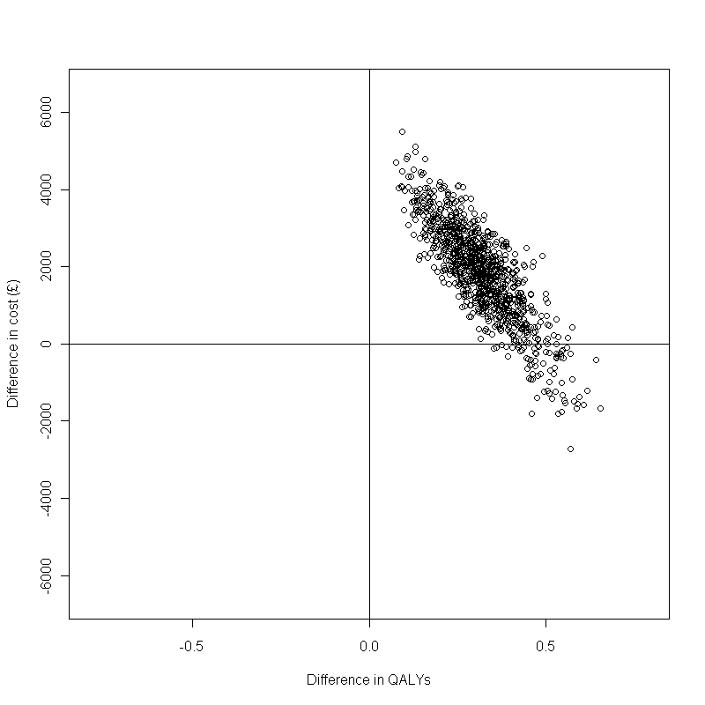

**Figure2b: PSA scatterplot for dabigatran in a population with a CHA2DS2-VASc score of 0**

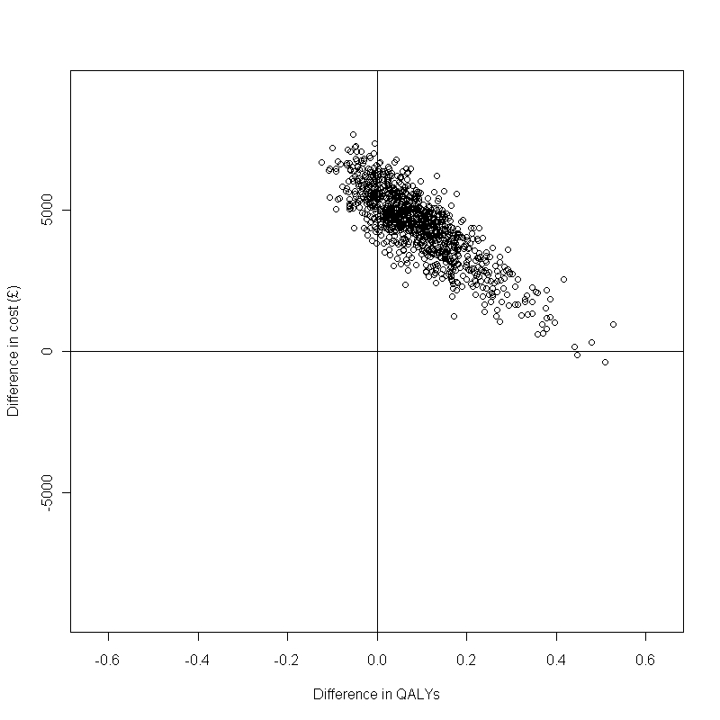

### CEACs and CEAFs

Figures 3a and 3b show the cost-effectiveness acceptability curves (CEACs) associated with TTE when compared with CHADS2 and CHADS2-VASc respectively. These show that, at the commonly quoted threshold of £20,000 per QALY, TTE has a high probability of being cost effective [Find number] when compared to CHADS2 alone; at this same threshold, however, TTE has only a low probability [find number] of being cost-effective when compared with CHADS2-VASc alone.

**Figure 3a: The CEAC for the use of TTE for dabigatran in patients with a CHADS2 score of 0**

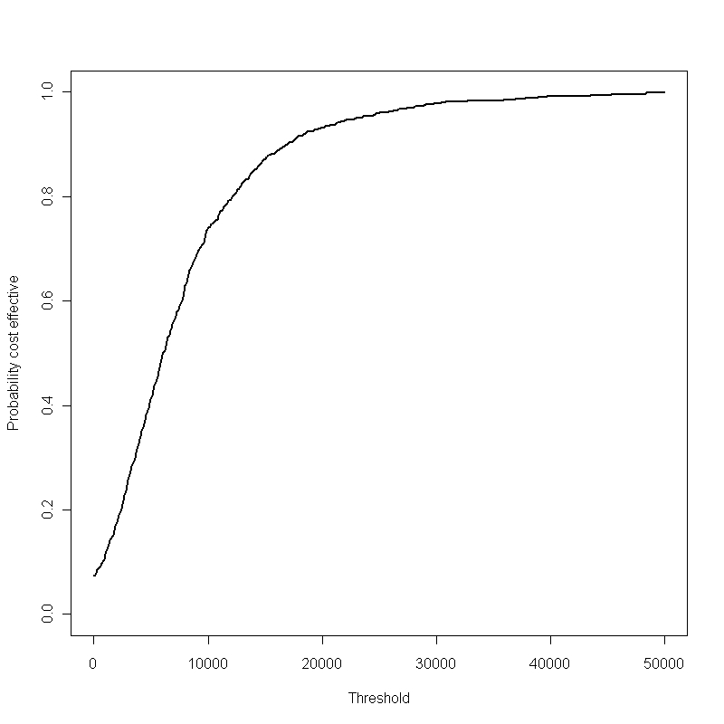

**Figure 3b: The CEAC for the use of TTE for dabigatran in patients with a CHA2DS2-VASc score of 0**

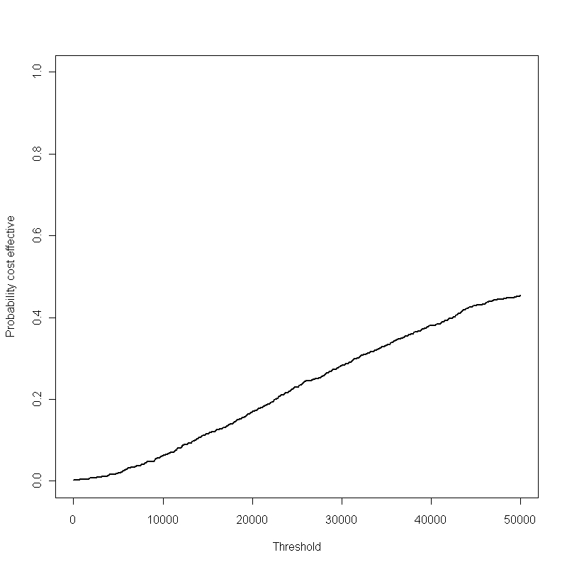

Figures 4a and 4b shows the cost-effectiveness acceptability frontiers (CEAFs) associated with CHADS2 and CHADS2-VASc respectively. Figure 4a indicates that the comparator strategy (CHADS2 + TTE, shown as a solid line) becomes the optimal strategy, compared with CHADS2 alone (the dashed line) at a wiliness to pay threshold of £5847 or more per QALY gained. Conversely, figure 4b indicates that the comparator strategy (CHADS2-VASc +TTE) has a low likelihood of being the optimal decision at threshold of lower than £50,000 per QALY gained, compared with CHADS2-VASc alone (the dashed line).

**Figure 4a: The CEAF for the use of TTE for dabigatran in patients with a CHADS2 score of 0.**

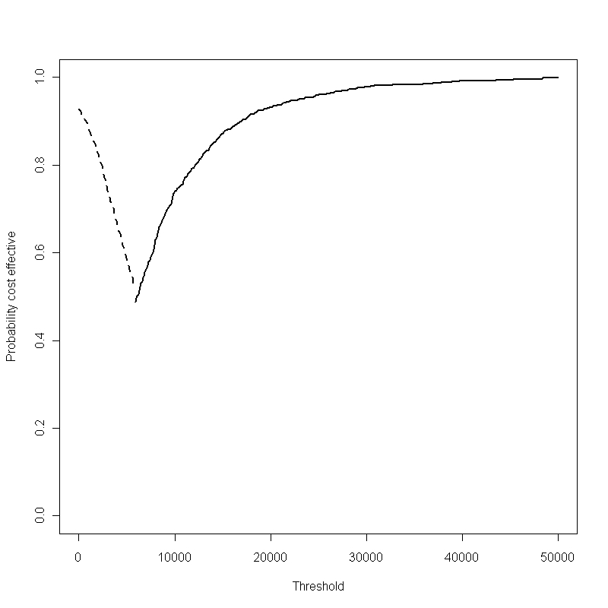

**Figure 4b: The CEAF for the use of TTE for dabigatran in patients with a CHA2DS2-VASc score of 0**

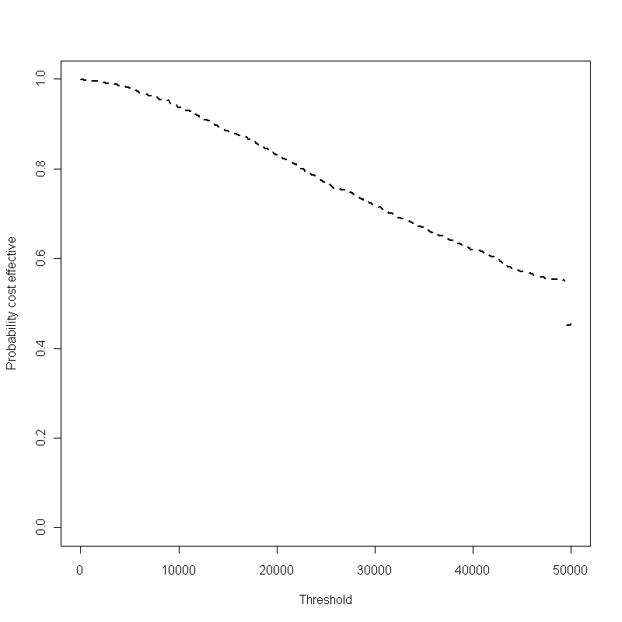

### EVPI

Figures 5a and 5b show, respectively, the per patient EVPI of TTE compared with CHADS2 alone and CHADS2-VASc alone. It is seen that there is most uncertainty at maximum acceptable incremental cost effectiveness ratios (MAICERs) close to the value at which TTE becomes cost effective. As the MAICER increases the value of EVPI falls substantially. Assuming that there are 70,000 people who would benefit from no uncertainty in the decision problem, the expected value of perfect information would be in the region of £5 million assuming a MAICER of £20,000 per QALY when using CHADS2 alone; the equivalent figure for CHADS2-VASc is in the region of £28 million.

**Figure 5a: The estimated per patient EVPI for dabigatran in patients with a CHADS2 score of 0.**

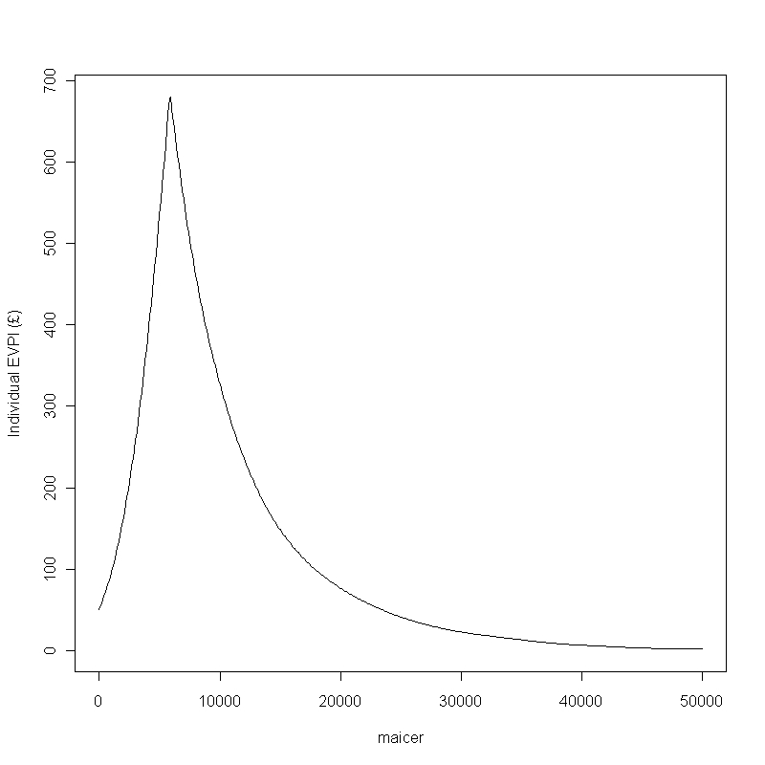

**Figure5b: The estimated per patient EVPI for dabigatran in patients with a CHA2DS2-VASc score of 0**

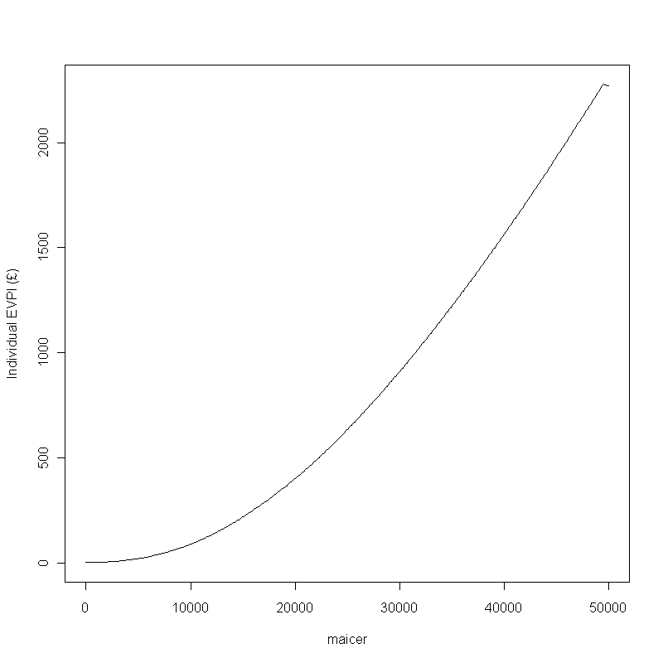

### Partial EVPPI

#### True HR Proportion

Figure 6a and 6b indicate the effect that different assumptions about the TPHR within the subgroup of the population with CHADS2 scores of zero and CHADS2-VASc scores of zero, respectively. For CHADS2 (Figure 6a) it is seen that at low proportions of patients with LA ABN that TTE is cost effective; even at zero percent TTE is cost effective indicating that there is an apparent benefit in treating those with a CHADS2 score of zero even when the patient does not have LA ABN. Conversely, for CHADS2-VASc (Figure 6b) it is seen that the proportion of patients with LA ABN needs to be close to 12.5% in order for the cost per QALY of TTE to be near £20,000. At present there are very little data on this parameter with 0 of 11 patients with a CHA2DS2-VASc score of 0 having LA ABN.

**Figure 6a: The change in the cost per QALY when different assumptions are made regarding the proportion of patients with a CHADS2 score of 0 who have LA ABN with dabigatran as OAC.**

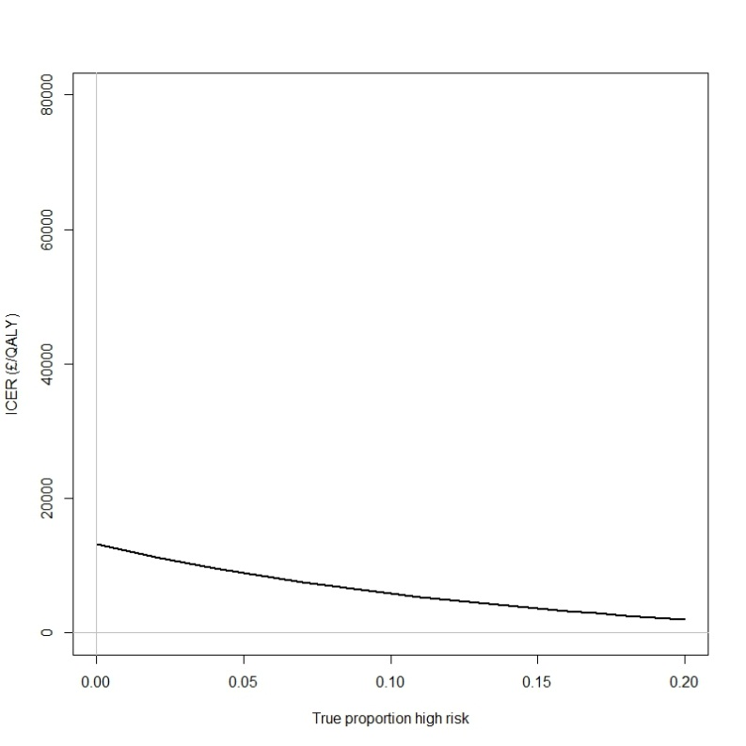

Figure 20 provides an indication of the change in the cost per QALY when different assumptions are made regarding the proportion of patients with a CHA2DS2-VASc score of 0 who have LA ABN.

**Figure 6b: The change in the cost per QALY when different assumptions are made regarding the proportion of patients with a CHA2DS2-VASc score of 0 who have LA ABN with dabigatran as OAC**

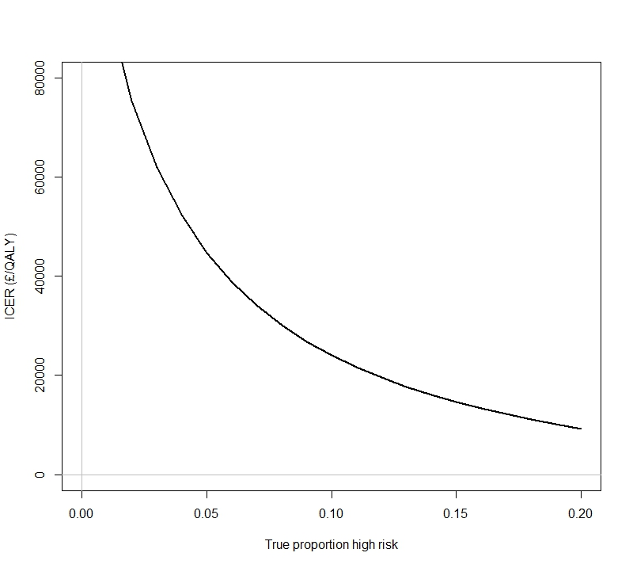

#### Sensitivity and specificity

The estimated expected ICERs also depend to a large extend on the sensitivity and specificity of TTE in identifying TPHR. Tables 6a and 6b show how the expected ICER changes as sensitivity and specificity are varied between zero and one, for CHADS2 and CHADS2-VASc respectively. Table 6a shows that, for CHADS2, barring a scenario where sensitivity equals 0 and specificity equals 1, which is identical to the non-TTE strategy, the cost per QALY is always under £20,000. Conversely, table 6b shows that, for CHADS2-VASc, the cost per QALY falls below £20,000 only when both sensitivity and specificity are relatively high. Whilst the specificity of TTE is estimated to be high (at approximately 0.95) the specificity is low (at approximately 0.34). The cost per QALY falls between £20,000 and £30,000, a range that may be considered cost effective158 on a small number of occasions.

**Table 6a An indication of the change in the cost per QALY when different assumptions are made regarding the sensitivity and specificity of TTE in identifying LA ABN**.[NICE…]

|  |  |  |  |  |  |  |  |  |  |  |
| --- | --- | --- | --- | --- | --- | --- | --- | --- | --- | --- |
| **Specificity** | | | | | | | | | | |
| 0 | 0.1 | 0.2 | 0.3 | 0.4 | 0.5 | 0.6 | 0.7 | 0.8 | 0.9 | 1 |
| **Sensitivity** | 0 | £13,211 | £13,236 | £13,267 | £13,307 | £13,360 | £13,434 | £13,545 | £13,730 | £14,101 | £15,213 | Infinite |
| 0.1 | £12,411 | £12,349 | £12,273 | £12,177 | £12,051 | £11,878 | £11,627 | £11,230 | £10,507 | £8,774 | Dominating |
| 0.2 | £11,673 | £11,540 | £11,376 | £11,171 | £10,906 | £10,551 | £10,050 | £9,289 | £7,997 | £5,317 | Dominating |
| 0.3 | £10,992 | £10,798 | £10,563 | £10,270 | £9,897 | £9,406 | £8,729 | £7,738 | £6,144 | £3,160 | Dominating |
| 0.4 | £10,361 | £10,116 | £9,821 | £9,458 | £9,001 | £8,408 | £7,608 | £6,470 | £4,720 | £1,686 | Dominating |
| 0.5 | £9,775 | £9,487 | £9,143 | £8,723 | £8,200 | £7,530 | £6,644 | £5,414 | £3,591 | £615 | Dominating |
| 0.6 | £9,230 | £8,905 | £8,519 | £8,053 | £7,479 | £6,753 | £5,806 | £4,521 | £2,675 | Dominating | Dominating |
| 0.7 | £8,720 | £8,365 | £7,945 | £7,442 | £6,827 | £6,058 | £5,071 | £3,756 | £1,917 | Dominating | Dominating |
| 0.8 | £8,243 | £7,862 | £7,414 | £6,880 | £6,234 | £5,435 | £4,421 | £3,093 | £1,278 | Dominating | Dominating |
| 0.9 | £7,795 | £7,392 | £6,921 | £6,364 | £5,693 | £4,872 | £3,843 | £2,514 | £733 | Dominating | Dominating |
| 1 | £7,375 | £6,953 | £6,463 | £5,887 | £5,198 | £4,362 | £3,324 | £2,003 | £263 | Dominating | Dominating |

**Table 6b An indication of the change in the cost per QALY when different assumptions are made regarding the sensitivity and specificity of TTE in identifying LA ABN.**

|  |  |  |  |  |  |  |  |  |  |  |
| --- | --- | --- | --- | --- | --- | --- | --- | --- | --- | --- |
| **Specificity** | | | | | | | | | | |
| 0 | 0.1 | 0.2 | 0.3 | 0.4 | 0.5 | 0.6 | 0.7 | 0.8 | 0.9 | 1 |
| **Sensitivity** | 0 | £125,321 | £125,447 | £125,605 | £125,809 | £126,079 | £126,459 | £127,028 | £127,976 | £129,873 | £135,562 | Infinite |
| 0.1 | £114,248 | £113,246 | £112,020 | £110,484 | £108,504 | £105,856 | £102,131 | £96,505 | £87,025 | £67,669 | £6,221 |
| 0.2 | £104,895 | £103,115 | £100,974 | £98,348 | £95,053 | £90,794 | £85,076 | £76,995 | £64,705 | £43,758 | £35 |
| 0.3 | £96,890 | £94,569 | £91,817 | £88,500 | £84,426 | £79,303 | £72,663 | £63,717 | £51,012 | £31,547 | Dominating |
| 0.4 | £89,962 | £87,263 | £84,102 | £80,348 | £75,819 | £70,247 | £63,223 | £54,096 | £41,754 | £24,137 | Dominating |
| 0.5 | £83,907 | £80,945 | £77,513 | £73,489 | £68,706 | £62,927 | £55,803 | £46,803 | £35,077 | £19,161 | Dominating |
| 0.6 | £78,569 | £75,428 | £71,821 | £67,638 | £62,729 | £56,886 | £49,816 | £41,086 | £30,033 | £15,589 | Dominating |
| 0.7 | £73,829 | £70,568 | £66,854 | £62,588 | £57,636 | £51,818 | £44,885 | £36,483 | £26,089 | £12,901 | Dominating |
| 0.8 | £69,591 | £66,254 | £62,482 | £58,185 | £53,244 | £47,503 | £40,752 | £32,697 | £22,920 | £10,804 | Dominating |
| 0.9 | £65,780 | £62,400 | £58,604 | £54,311 | £49,418 | £43,787 | £37,238 | £29,529 | £20,319 | £9,123 | Dominating |
| 1 | £62,334 | £58,935 | £55,141 | £50,878 | £46,055 | £40,552 | £34,214 | £26,838 | £18,145 | £7,746 | Dominating |

### Summary

These results indicate that the cost effectiveness of TTE in this context depends on the baseline strategy assumed, with results indicating TTE is cost effective when compared with CHADS2 alone, but not when compared with CHADS2-VASc alone.

## Discussion:

### Summary of what found

Our model indicates that, when it was assumed that the CHADS2 tool was used, the addition of TTE with the aim of identifying patients with LA ABN was deemed cost effective with the mean cost per QALY below £20,000 for all analyses and a low probability of the cost per QALY being greater than £20,000. Conversely, when the CHA2DS2-VASc tool was used, the addition of a TTE was not considered cost effective with the mean cost per QALY being greater than £30,000 for all analyses, and often considerably higher. However, there is considerable uncertainty in this conclusion due to the dearth of data, particularly in the proportion of patients with LA ABN and a CHA2DS2-VASc score of 0, as there were only 11 patients with a CHA2DS2-VASc of zero.

### Shortcomings

Our model has a range of shortcomings and limitations. Assumptions have been made within the modelling. For example, the risk of stroke associated with a CHA2DS2-VASc score was assumed to be equal to that associated with the identical CHADS2 score, which is incorrect as the CHA2DS2-VASc is incremented by one when the person is 65 years, with the corresponding age for a unit increment in the CHADS2 score is 75 years. The dose of dabigatran was set at 150mg twice daily, rather than allowing some patients to receive a lower dose of 110mg twice daily; the model could be adapted to reduce the dose when a patient reaches a specified age. The stroke risk associated with patients with left atrial abnormalities is assumed to be constant at 8.0% (95% CI: 7.26 – 8.31) per year; ideally differential rates by age or by the number (and type) of abnormalities would be used but these data were not identified.

Perhaps a stronger assumption made in producing the model is that TOE is a perfect gold standard against which the sensitivity and specificity of TTE should be derived. Using this assumption, TTE was estimated to have a very high sensitivity but a specificity of only around 35%. Within our model, this low specificity corresponds to an increased proportion of ‘false positives’ being included in the patient population mix, and so TTE results in more people effectively experiencing increased risks of OACs in terms of bleed risks without corresponding increased benefits in terms of stroke risk reduction. If TTE were found to be superior to TOE at identifying certain types of LA ABN which expose patients to increased stroke risks, then this modeling assumption may be inaccurate. The key data on which this economic evaluation is based – sensitivity, specificity, and TPHR – is a relatively small study, of fewer than 400 patients, and in the group of interest, those patients who would be given a CHADS2 or CHA2DS2-VASc score of 0, fewer than 25 patients, and fewer than 80 patients with a CHADS2 or CHA2DS2-VASc score of 1. This has made the assessment of the benefits of TTE uncertain, particularly in addition to the use of CHA2DS2-VASc, which had the fewer number of patients.

Other limitations include that there were no data relating the risk of stroke with CHA2DS2-VASc score, and this was approximated using the risk of stroke associated with CHADS2 score; that the risk of death unrelated to bleeding or stroke events was taken from lifetables and were not adjusted for the probability of bleeding or stroke mortality; and that the patient groups analysed within the model was limited, being males aged 60 with a CHADS2 or CHA2DS2-VASc score of 0 or 1.

### How relates to other findings

Prior to producing this model, a systematic literature review was conducted to identify, summarise and appraise existing economic studies for evaluating the cost-effectiveness of TTE in patients with AF. This review identified no economic evaluations of TTE in AF patients, so it is believed that this is the first.

### Implications for Research

Sensitivity analyses of our model results indicate that our estimates are significantly affected by uncertainty in our knowledge about the sensitivity and specificity of TTE in this context, as well as the proportion of patients with LA ABN whom CHADS2 and CHADS2-VASc identify as low risk. However, our results also indicate that whether there is significant value in conducting this research depends on whether a reduction in our uncertainty about parameters will lead to a substantial reduction in decision uncertainty. When CHADS2 alone is used as the baseline strategy, the MAICER at which the +TTE strategy becomes cost effective is significantly below the £20,000 threshold; when CHADS2-VASc alone is the baseline strategy the MAICER at which the +TTE strategy becomes cost effective is significantly above the £20,000 threshold. In this sense our estimates suggest reductions in parameter uncertainty may not lead to large reductions in decision uncertainty. However, our model depends strongly on data reported in a single, relatively small study conducted outside of the UK, and so may under-represent the true level of uncertainty we have about sensitivity, specificity and TPHR. These parameters have been shown to markedly affect the cost per QALY and there are few data available. In obtaining such data more accurate estimates of the sensitivity and specificity of TTE in identifying LA ABN should be collected. The risks of stroke associated with each CHA2DS2-VASc score also needs to be determined, at present no values have been identified, which may limit the uptake of the CHA2DS2-VASc tool compared with the CHADS2 tool. Any additional benefit of TTE further to those associated with treatment for stroke prevention also needs to be researched. Even small gains would equate to TTE being perceived as cost effective.

### Implications for clinical practice

[Unclear… need to think about a bit more before writing.]

The assessment of newly diagnosed patients with AF with a TTE is unlikely to cause a significant impact to either the NHS or other parties. TTEs are relatively easily available as well as both safe and non-invasive for patients, with staff trained in their use likely to be already available in hospitals.

The additional resources required are relatively small, at an estimated £66 per TTE performed. It is likely that additional bed days are made available due to the reduction in stroke following appropriate management, although there is likely to be an increase in bleed related admissions.

Our conclusions have little implications for service provision. Should TTE be recommended for those patients with CHADS2 or CHA2DS2-VASc scores of 0 or 1, this is unlikely to place a great burden on hospitals who are likely to have staff trained in the use of TTE machines.

A key uncertainty is whether there are other benefits that are accrued from a TTE other than identifying LA ABN. If these exist, and produce even small QALY gains (> 0.0033) then TTE would be cost effective in all scenarios.

As TTE is relatively easily available and is a safe and non-invasive diagnostic, no other relevant factors were identified.

### Final paragraph

[Also to think about and discuss before writing]